**Archimate**

***What is Archimate?***

***What is enterprise architecture?***

* Enterprise architecture is the process by which organizations standardize and organize IT infrastructure to aligns with business goals.
* The **purpose** of enterprise architecture is to create a map of IT assets and business processes and a set of governing principles that drive an ongoing discussion about business strategy and how it can be expressed through IT.
* Four domains of enterprise architecture are:
* business,
* information/data,
* application/integration and
* technical/infrastructure
* ArchiMate is a modelling technique (“language”) for describing enterprise architectures. It presents a clear set of concepts **within** and relationships **between** architecture domains, and offers a simple and uniform structure for describing the contents of these domains.
* **Archimate 1**

1. The **Business layer** offers products and services to external customers, which are realized in the organization by business processes performed by business actors and roles.
2. The **Application layer** supports the business layer with application services which are realized by (software) application components.
3. The **Technology layer** offers infrastructural services (e.g., processing, storage and communication services) needed to run applications, realized by computer and communication hardware and system software.

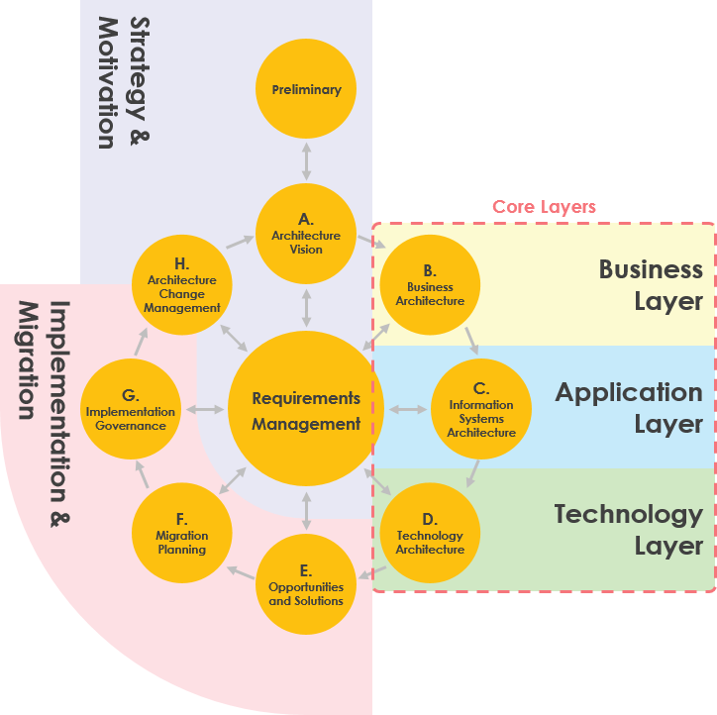

* **Archimate 3.0 (Latest)**

In the new ArchiMate, the enterprise architecture model is split into six layers:

1. Strategy
2. Business
3. Application
4. Technology
5. Physical
6. Implementation & Migration

* Strategy layer (Capability, Resource, Course of Action)
* Physical Layer to model physical elements; for example, manufacturing, logistics, and other physical environments.
* An *Implementation and Migration Viewpoint* model relate programs and projects to the parts of the architecture that they implement. This view allows modeling of the scope of programs, projects, project activities

**Aspects**

**The second dimension is made up of 3 aspects**

1. **Active Structure**   
   **Active structures** captures subjects that display actual behavior (who?). These active structures are represented using **boxes with square corners** and an icon in the upper-right corner.
2. **Behavior Structure**   
   **Behavior aspects** *represents behaviors* of active structures (how?) and are visualized using **boxes with round corners**and an icon in the upper-right corner.
3. **Passive Structure**   
   **Passive structures** are the objects behavior is performed on (what?). There is no global way to visualize them with regards to the shape.

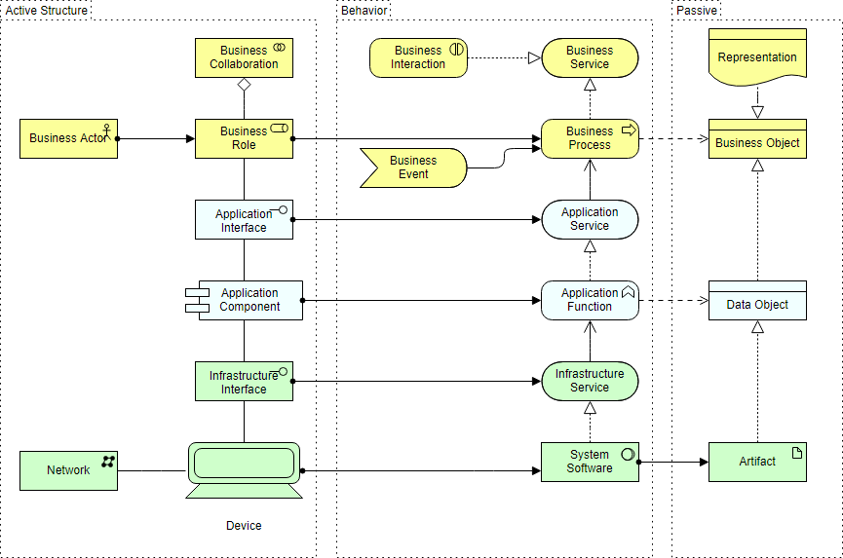

1. The **Motivation** Extension (Drivers, Goals, Requirements, Principles, etc.) has been introduced in ArchiMate 2. The Motivational concepts are used to model the motivations, or reasons, that underlie the design or change of some enterprise architecture. The motivation extension adds motivational concepts such as goal, principle, and requirement. It corresponds to the “Why” column of the Zachman framework

*REFERENCES*

[*https://online.visual-paradigm.com/diagrams/tutorials/archimate-tutorial/*](https://online.visual-paradigm.com/diagrams/tutorials/archimate-tutorial/) *(Main document)*

*Archimate fundamental video by openGroup (short video):* [*https://www.youtube.com/watch?v=N0y-QQK4fnk*](https://www.youtube.com/watch?v=N0y-QQK4fnk)

[*https://pubs.opengroup.org/architecture/archimate31-doc/chap04.html*](https://pubs.opengroup.org/architecture/archimate31-doc/chap04.html) *(To understand about notation)*